**FinSecure: A Proposal for a Regulated Intermediary and Integration of Blockchain Principle's**

Abstract:

This research paper examines the need for a fast, secure, and transparent payment system to accommodate the demands of modern-day living. The Unified Payments Interface (UPI) was introduced by the National Payments Corporation of India (NPCI) in April 2016, enabling seamless money transfers via the internet and smartphones. During the COVID-19 pandemic, UPI usage rose exponentially, facilitating a path towards a cashless economy in India. In October 2022, UPI had nearly 7.3 billion transactions. Despite its technological advancements, UPI has experienced some setbacks, including issues with intermediaries causing transactions to become stuck and fraudulent practices resulting from a lack of financial literacy among Indians. This paper proposes the introduction of a single intermediary regulated by the Reserve Bank of India (RBI) with additional security features and binding methods that provide a secure, reliable, transparent, and fast mechanism for transferring money. It also suggests holding money in the intermediary until certain conditions are met using smart contracts. Additionally, the paper discusses solutions to promote the use of central bank digital currency (CBDC) and a mechanism built on top of the proposed solution using blockchain technology to provide a tamper-proof ledger, transparent, secure, and efficient way to transfer funds among peers, international transfers, B2B, B2C, etc. The aim is to create a more efficient and secure payment system that can accommodate the needs of modern-day living.

1 Introduction:

For daily transactions in a world that is progressively going digital, effective and secure payment methods are essential. In order to meet these expectations, India unveiled the Unified Payments Interface (UPI) in April 2016. This technology enables secure money transfers via an internet-connected smartphone. However, UPI encountered a number of difficulties, including issues with middlemen that caused transactions to become blocked and fraudulent practises brought on by Indians' low level of financial knowledge. In order to address these problems and advance the adoption of blockchain technology and central bank digital currency (CBDC), this research suggests a brand-new payment method that can improve India's payment system's effectiveness and dependability. The inclusion of too many middlemen, which causes problems with money becoming trapped in the transaction processing phase, is one of the main problems with UPI. Additionally, fraudulent practises exist where the receiver must have a distinct UPI ID, which is readily delinked from a user's account and could result in fraud. These issues limit the effectiveness and dependability of the country's current payment system, which cannot meet the demands of modern living since it is not secure or trustworthy. The proposed payment solution involves the establishment of a single intermediary under RBI regulation with extra security features and binding techniques to overcome these problems and offer a safe, dependable, clear, and quick means for money transmission. Until specific requirements, such as the successful execution of the transaction or the receiver's certification of receipt, are met, the intermediary would hold funds. The funds would be transferred to the recipient if these requirements are satisfied, enhancing the security and dependability of transactions and fostering a sense of confidence between the payer and the recipient. The suggested payment system would also employ blockchain technology to increase transaction security by creating a tamper-proof ledger, a transparent, secure, and effective method for peer-to-peer transfers, international transfers, B2B and B2C transactions, etc. By eliminating the need for middlemen, blockchain technology would enable quicker and more effective transactions. The possible effects of CBDCs on cybersecurity, financial stability, and privacy, however, have raised some worries. The People's Bank of China and the European Central Bank are two central banks that have begun experimenting with CBDCs, but there is still much to learn before a full-scale deployment can be accomplished. The proposed payment method would develop a more reliable and effective payment system in India, addressing the demands of contemporary living and encouraging the usage of CBDCs and blockchain technology. The problem would be solved, and it would deal with intermediary problems, fraud, and the lack of financial literacy that the Indian payment system is currently experiencing. While there are concerns about the possible effects of CBDCs, using smart contracts and blockchain technology will improve the security and dependability of transactions, resulting in quicker and more efficient transactions.

2 Related Work:

The research on the Unified Payments Interface (UPI), central bank digital currencies (CBDCs), and enhancements to UPI 2.0 emphasises the promise of these technologies in modernising payment systems, enhancing their effectiveness and security, and fostering financial inclusion. Blockchain technology is a decentralised, distributed ledger system that has advantages in terms of efficiency, security, and transparency. CBDCs are a type of digital currency created and governed by central banks with the objective of facilitating quicker and more secure transactions while minimising reliance on actual currency. Numerous updates to UPI have been made, most notably UPI 2.0, which included a number of new capabilities to address problems with the country's existing payment system. The possibility of these technologies in payment systems has been examined in several research. A blockchain-based payment system for microfinance organisations was suggested by Ahmed et al. (2020), which can lower transaction costs and broaden financial inclusion. A hybrid CBDC model that combines the advantages of both wholesale and retail CBDCs was suggested by Engert et al. (2020) after discussing the advantages and difficulties of CBDCs. UPI has significantly increased the number of digital payments, according to Chandrasekhar et al. (2020), who studied the effect of UPI on Indian payment systems. The combination of CBDCs and blockchain technology in the proposed payment solution makes it distinct and possibly more effective than previous payment systems. Additionally, the emphasis on security and dependability in the suggested payment solution is particularly pertinent in a nation like India where confidence in digital payment systems is still growing. However, there are a number of security and privacy issues raised by the use of CBDCs and blockchain technology. The suggested payment solution allays these worries by establishing a single intermediary under RBI regulation with additional security features and binding techniques that offer a safe, dependable, clear, and quick means for money transfer.

3 Solution:

Worldwide adoption of electronic payment methods is on the rise, and India is no exception. However, the multi-stage transaction method used by India's present payment system can result in delays and longer transaction times. The suggested remedy for this problem proposes using a single intermediary to simplify payments and boost transaction efficiency. The sum is now debited from the Remitter Bank when a user requests a transaction from a Payer Payment Service Provider (PSP). This request is then sent to the National Payments Corporation of India (NPCI) server. The beneficiary bank is updated by the NPCI servers to credit the payee's account, and the request is then transmitted to the Payee PSP, where the account to which the money is to be credited is determined. Due to the possibility of intermediaries' unavailability, this multi-stage process can result in delays and longer transaction timeframes. In order to reduce the number of intermediaries engaged in the transaction process, the suggested solution calls for the use of a single intermediary to operate as a middleman between the payer and payee. This would speed up transactions and lower the likelihood of problems with availability. The suggested system also strives to raise the security, trust, and transparency of electronic payments. The transaction process is made more transparent and safer by the addition of a single intermediary because the intermediary would be in charge of confirming the specifics of the transaction. The suggested approach would also aid in developing a payment system that is more effective and dependable. All parties involved in the payment process—consumers, retailers, and financial institutions—would benefit from this. Faster transactions would be possible with a more effective payment system, cutting down on transaction times and improving the overall efficiency of the payment process. The implementation of smart contracts can increase the suggested solution's security and dependability even more. Smart contracts are self-executing agreements that employ computer code to enforce their terms, doing away with the necessity of a middleman. The proposed approach can potentially improve transaction security and safety by incorporating blockchain technology. For enhancing security and safety, blockchain technology enables decentralisation, tamper-proof ledgers, and smart contracts. The suggested approach of adding a single intermediary to consolidate the payment process and boost transaction efficiency, along with the application of smart contracts and blockchain technology, can aid in developing a more secure, effective, dependable, and transparent payment system in India. This would help the economy transition to a digital economy and benefit all parties engaged in the payment process.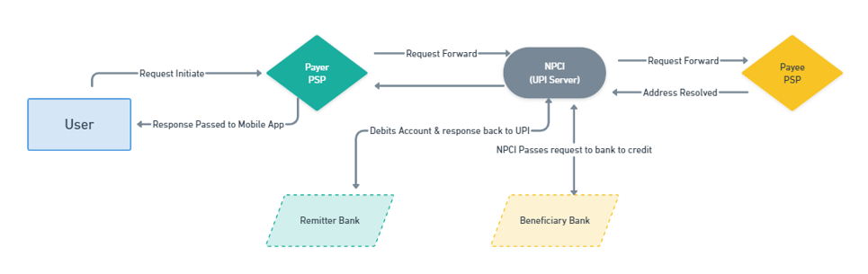

Fig. Current UPI Transaction Process

3.1 FinSecure

A more effective, secure, and dependable payment mechanism is crucial in today's digital environment. Multiple middlemen are being used in India's transaction process, which causes delays and extends transaction times. The proposed remedy to this problem is the introduction of FinSecure, a separate intermediary that seeks to consolidate intermediaries in order to boost transaction efficiency and speed. In order to avoid the use of multiple intermediaries, FinSecure maintains a central database that is accessible by all recognised financial institutions. The core of the suggested approach is a central database that houses all user account data. The introduction of Blockchain technology would increase the security of the payment system and make data tampering nearly impossible. A more effective, dependable, and transparent payment system will be produced as a result of the suggested solution, which will be advantageous to all parties engaged in the transaction, including customers, businesses, and financial institutions.

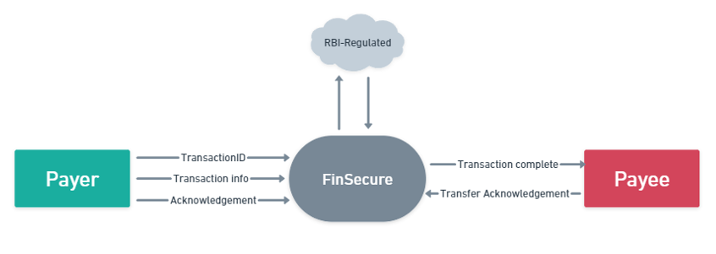

Fig. Context Diagram for FinSecure

A payment platform called FinSecure uses a variety of technologies, including regulated decentralisation, tamper-proof ledgers, and smart contracts, to offer its users a safe and effective payment system. Controlled decentralisation is the process of distributing information and resources among several servers or nodes as opposed to depending solely on one central location. By allowing selective sharing of information and lowering the possibility of unauthorised access, this technique lowers the vulnerability of data to hackers, system failures, or natural disasters while simultaneously ensuring data privacy. Controlled decentralisation implementation calls for thorough planning and coordination, but with the correct equipment and knowledge, it can offer a highly effective method of protecting data and reducing risks. Blockchain-based tamper-proof ledgers offer a transparent and unchangeable record of all network transactions, prohibiting any unauthorised alterations or tampering. Due to its potential to revolutionise a number of areas, including finance, healthcare, and supply chain management, tamper-proof ledgers have attracted a lot of interest lately. In order to maintain a tamper-proof ledger and ensure its integrity while protecting user privacy and confidentiality, FinSecure uses intermediaries. Tamper-proof ledgers provide better data security, more openness, less fraud, and simplified procedures, which can result in cost savings and higher productivity. Peer-to-peer transactions, smart contracts, and tokenization are a few examples of new business models and revenue streams that can be enabled by tamper-proof ledgers. Smart contracts are agreements that automatically carry out their provisions and are composed entirely of code. By enabling automated, trustless transactions between parties, they do away with the need for middlemen and lower the danger of fraud. FinSecure can provide an extra layer of security and trust to the payment process by utilising smart contracts to ensure that funds are only delivered when certain criteria are satisfied. Finance, real estate, and supply chain management are just a few of the sectors that smart contracts have the potential to revolutionise. New business models and revenue streams like peer-to-peer lending, crowdfunding, and tokenization can be made possible by them. Traditional payment systems frequently call for a number of middlemen and manual processing, which adds time and expense to the process. Smart contracts can greatly decrease these costs and time constraints. By utilising smart contracts, FinSecure offers a safe and effective way for payers and payees to transact, increasing transparency, lowering the possibility of fraud, and boosting the effectiveness of payment systems. Overall, FinSecure makes use of cutting-edge technologies to offer its users a safe and effective payment solution. Improved data security, better transparency, less fraud, and faster operations are all benefits of controlled decentralisation, tamper-proof ledgers, and smart contracts. These advancements can also result in cost savings and increased efficiency. FinSecure is increasing the trust and confidence of its clients and partners while also expanding its chances for growth and innovation by utilising these technologies.

FinSecure is an independent intermediary that facilitates transactions between payers and payees. It is regulated by the Reserve Bank of India and operates with the aim of creating a secure and efficient transaction process. FinSecure operates with two major duties, registration and transaction, which we will discuss in detail in the following sections.

3.2 Registration Process

The registration process is the first step in using FinSecure's services. It involves the input of account details, such as personal information, banking details, and other relevant data. The data is then stored in a decentralized database that maintains a continuously growing list of records or transactions. As you can view in Fig. 3 upon arrival of the data, the Value-Binder function runs and creates a unique Binding-Value for each account. Each user account is associated with a different value, much like how each transaction on a ledger or a block in a blockchain has a unique id, even if the user is the same. The binding value is generated using a cryptographic algorithm, which ensures that it is unique and tamper-proof. Once the binding value is generated, it is mapped with the account details, and the database is updated. The mapping of binding values to account details helps in the retrieval of account information in the database. It also helps to maintain the integrity of the database as the binding value acts as a unique identifier for each account. The decentralized database used in FinSecure is a key feature of the system. Decentralized databases are gaining attention in recent years because they offer better scalability, fault tolerance, and resilience to attacks. These databases are distributed across multiple nodes, making them less vulnerable to single-point failures or cyberattacks. In a decentralized database, there is no central authority that controls the data, making it more transparent and less susceptible to fraud. Transactions are validated by the network, and consensus is achieved through a distributed consensus algorithm. Blockchain technology, which powers FinSecure, is an example of a decentralized database that offers a transparent and immutable record of all transactions that occur on the network. The registration process of FinSecure is a critical step in ensuring the security and efficiency of digital transactions. The process involves the input of account details, the generation of unique binding values, and the storage of account information in a decentralized database. Decentralized databases are gaining attention in recent years because they offer better scalability, fault tolerance, and resilience to attacks. Blockchain technology, which powers FinSecure, is an example of a decentralized database that offers a transparent and immutable record of all transactions that occur on the network.

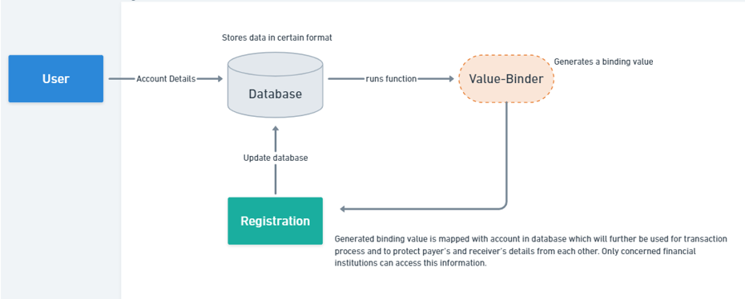

Fig. Registration Process of FinSecure

3.3 Transaction Process

In Fig. 4, the transaction process begins when a registered user initiates a transaction. The user sends transaction details, such as the transaction amount, address, and id, to the payer. The transaction information then arrives at the intermediary, which is responsible for verifying that the transaction's conditions have been met. This verification process involves checking the smart contract details associated with the transaction, which specify the conditions that must be met for the transaction to be considered complete. Smart contracts are self-executing programs that run on a blockchain network and can be used to automate various tasks, including financial transactions. They are a key component of blockchain-based systems, as they enable transactions to be executed automatically when certain conditions are met, without the need for intermediaries or third-party validators. Smart contracts are often used in decentralized finance (DeFi) applications, which are financial services that operate on blockchain networks and are designed to be open, transparent, and accessible to anyone with an internet connection. In the context of FinSecure, smart contracts are used to ensure that transactions are executed according to the agreed-upon terms and conditions. When a user initiates a transaction, the intermediary checks the smart contract associated with that transaction to determine whether the conditions for executing the transaction have been met. If the conditions have been met, the funds are transferred from the payer to the payee. If the conditions have not been met, the transaction is cancelled, and the funds are returned to the payer. The use of smart contracts in financial transactions has several benefits. First, it eliminates the need for intermediaries, such as banks or other financial institutions, which can reduce transaction costs and increase efficiency. Second, it enables transactions to be executed automatically and securely, without the need for human intervention. This reduces the risk of fraud and errors, and increases the transparency and accountability of the transaction process. Finally, smart contracts can be used to create complex financial instruments, such as derivatives, that are difficult or impossible to create using traditional financial systems. However, the use of smart contracts in financial transactions also presents several challenges. One of the biggest challenges is the lack of legal clarity around smart contracts. Because smart contracts are self-executing and operate on a blockchain network, it can be difficult to determine which legal jurisdiction they fall under and which laws apply to them. This can create uncertainty for users and may limit the adoption of smart contracts in certain industries. Another challenge is the potential for bugs or vulnerabilities in smart contract code. Smart contracts are written in programming languages and are subject to the same types of errors and vulnerabilities as other software. If a smart contract contains a bug or vulnerability, it can be exploited by malicious actors, leading to loss of funds or other negative outcomes. Therefore, it is important to thoroughly test smart contracts and to have mechanisms in place for detecting and mitigating security risks. The use of smart contracts in financial transactions has the potential to revolutionize the way we conduct financial transactions. By enabling transactions to be executed automatically and securely, without the need for intermediaries, smart contracts can reduce transaction costs, increase efficiency, and increase transparency and accountability. However, the use of smart contracts also presents several challenges, including legal uncertainty and security risks. Therefore, it is important to carefully consider the benefits and risks of using smart contracts and to take steps to mitigate potential risks.

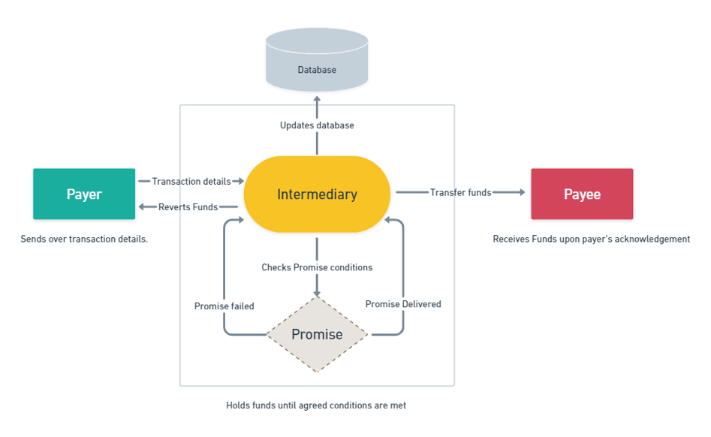

Fig. New Payment System with FinSecure

FinSecure offers a secure and efficient transaction process by using a tamper-proof ledger that maintains a transparent and immutable record of all transactions. The registration process involves generating unique identifiers for accounts, which are mapped to a decentralized database. The transaction process involves the use of smart contracts to ensure that the promise is fulfilled before transferring funds to the payee. The use of blockchain technology in FinSecure's operations ensures increased security, transparency, and efficiency. The potential of blockchain technology in transforming the financial industry has been widely recognized, and research in this area is ongoing. For example, research has shown that blockchain technology can be used to improve cross-border payments, reduce transaction costs, and increase financial inclusion. The adoption of blockchain technology in financial systems is expected to continue to grow in the coming years.

4 Results:

The implementation of a blockchain-based intermediary system in financial transactions has the potential to revolutionize the way business is conducted. This is because the technology underlying blockchain provides unparalleled security and transparency in transactions, as each transaction is recorded and verified by multiple nodes in a decentralized network. By introducing such a system, the trust between small time manufacturers and customers can be increased, as it becomes more difficult for dishonest actors to cheat the system. One of the main benefits of using blockchain technology is the increased transparency it provides in transactions. Each transaction is recorded on a decentralized ledger, which means that it is viewable by anyone on the network. This level of transparency allows for greater accountability in financial transactions, as it becomes more difficult for individuals or businesses to engage in fraudulent behaviour. The use of blockchain technology can also increase the reliability of transactions, as it creates an immutable record of all transactions that cannot be tampered with. Moreover, by implementing a blockchain-based intermediary system, businesses can build a more transparent and better solution for customers. This can lead to increased sales, as customers are more likely to trust and do business with companies that use transparent and secure payment systems. It also benefits businesses by reducing the cost of traditional payment processing, as the decentralized nature of blockchain technology reduces the need for intermediaries and third-party payment processors. For example, in 2021, Walmart Canada announced that it would be implementing a blockchain-based payment system for its supply chain. This system, called the Walmart Canada Blockchain, is designed to increase transparency and traceability in the supply chain by tracking product information, such as origin, batch numbers, and shipping details. This system is expected to increase the efficiency and transparency of the supply chain, while also reducing costs and improving customer trust. Lastly, the implementation of a blockchain-based intermediary system can also promote the adoption of central bank digital currency (CBDC) based payment systems. CBDCs are digital currencies issued by central banks, which operate on a blockchain or distributed ledger technology. The implementation of a blockchain-based intermediary system can be easily built on top of CBDCs by having some technological changes that can benefit a lot to RBI and India culture. By providing a secure and transparent payment system, CBDCs can potentially reduce the costs and improve the efficiency of financial transactions, while also promoting financial inclusion for the unbanked and underbanked populations. The implementation of a blockchain-based intermediary system can increase transparency, reliability, and security of financial transactions. It can improve the trust between small time manufacturers and customers, increase sales, and reduce the costs of traditional payment processing. Moreover, it can promote the adoption of CBDC-based payment systems, leading to greater financial inclusion and economic growth.

5 Future Scope:

Finsecure has the potential for several future research and development applications. One such application is the introduction of a Central Bank Digital Currency (CBDC) based payment system over the existing system. CBDC is a digital currency issued by the central bank, which can be used for transactions, just like physical cash. The introduction of a CBDC-based payment system can offer several advantages, including lower transaction costs, increased security, and faster transaction processing times. Moreover, CBDC can help eliminate the need for intermediaries in payment transactions, thus reducing the costs associated with payment processing. Another future scope for Finsecure is linking of UPI ID with Binding Value to result in a more secure environment to protect user data and address different issues presented in the UPI system. For example, Finsecure can help address the issue of de-linking of impersonated UPI IDs that can lead to fraud. With the help of Finsecure's unique Binding Value, each account can be linked to a unique identifier that can help prevent fraud and unauthorized access to user data. Furthermore, Finsecure can help provide a more efficient and secure payment system that can benefit not only individuals but also businesses. With the help of Finsecure, businesses can conduct transactions with increased transparency, reliability, and security. This can help reduce the risk of fraud, increase trust between parties, and promote a more seamless and efficient payment system. Overall, the future scope of Finsecure is vast and has the potential to revolutionize the way payments are conducted in India. By introducing CBDC-based payment systems and linking UPI IDs with Binding Value, Finsecure can provide a more secure, efficient, and reliable payment system that can benefit individuals, businesses, and the Indian economy as a whole.

Additional to the above benefits incremental research on FInsecure can be on topics like:

1. Integration with DeFi: Decentralized finance (DeFi) protocols can offer various financial services, including lending, borrowing, and trading. By integrating with DeFi, Finsecure can enhance its capabilities and offer these services to its users. This can increase the efficiency of financial transactions and provide users with more options.
2. Cross-border payments: Finsecure can expand its services to support cross-border payments, which can enable users to send and receive payments globally. This can promote international trade and commerce, making it easier for businesses and individuals to transact with each other across borders.
3. Integration with IoT: The integration of Finsecure with the Internet of Things (IoT) can facilitate secure and automated payments for various IoT devices. This can promote the growth of smart cities and homes by enabling users to make payments for various IoT services automatically, without the need for manual intervention.
4. Digital identity verification: Finsecure can leverage blockchain technology to develop a digital identity verification system. This can enhance the security of transactions and reduce fraud by providing a tamper-proof record of users' identities.
5. Supply chain management: Finsecure can offer supply chain management solutions, which can enhance the transparency and efficiency of supply chain operations. This can enable businesses to track the movement of goods and make payments for them automatically, reducing the risk of fraud and errors.
6. Micropayments: Finsecure can develop micropayment solutions, which can enable users to transact small amounts of money efficiently. This can promote financial inclusion by making it easier for users to access financial services and make small transactions.
7. Smart contracts: The use of smart contracts can enable Finsecure to automate various business processes, including payments. This can reduce costs and enhance efficiency by eliminating the need for manual intervention in these processes.
8. Integration with AI: The integration of Finsecure with Artificial Intelligence (AI) can facilitate intelligent decision-making, fraud detection, and risk management. This can enhance the security of financial transactions and provide users with more accurate and personalized financial services.
9. E-commerce solutions: Finsecure can offer e-commerce solutions, which can enable secure and fast transactions for online shoppers. This can provide users with a seamless shopping experience by integrating with popular e-commerce platforms.
10. Mobile payments: Finsecure can develop mobile payment solutions, which can enable users to make payments using their smartphones. This can promote convenience and ease of use by eliminating the need for physical cash or cards.

6 Conclusion:

In conclusion, this research paper has highlighted the challenges faced by the current payment system in India, specifically the issues related to intermediaries causing transaction delays and fraud resulting from a lack of financial literacy among Indians. To address these issues, the paper has proposed the introduction of a single intermediary regulated by the Reserve Bank of India (RBI) with additional security features and binding methods to provide a secure, reliable, transparent, and fast mechanism for transferring money. Moreover, the paper has discussed solutions to promote the use of central bank digital currency (CBDC) and the implementation of blockchain technology to provide a tamper-proof ledger, transparent, secure, and efficient way to transfer funds among peers, international transfers, B2B, B2C, etc. The proposed payment solution has the potential to revolutionize the payment industry in India by providing a secure and efficient payment system while promoting the adoption of CBDC and blockchain technology. Overall, the proposed payment solution has the potential to overcome the challenges faced by the current payment system in India while promoting financial inclusion, increasing financial literacy, and strengthening the Indian economy. The successful implementation of this payment solution can provide a template for other countries to improve their payment systems and promote the adoption of CBDC and blockchain technology. It is important for the Reserve Bank of India to carefully consider the proposed payment solution and work towards implementing it to improve the payment system in India.

7 References:

1. Biswas, M. (2020). The potential of central bank digital currencies in the payment system. The Journal of Payments Strategy & Systems, 14(1), 33-45. doi: 10.1108/JPSS-07-2019-0072
2. Capgemini. (2020). World Payments Report 2020. Retrieved from <https://www.capgemini.com/wp-content/uploads/2020/09/World-Payments-Report-2020.pdf>
3. Chakrabarty, D., & Singh, S. K. (2020). Blockchain in the era of digital India. In Handbook of Blockchain, Digital Finance, and Inclusion (pp. 333-352). Academic Press. doi: 10.1016/B978-0-12-819445-8.00018-6
4. Chakraborty, I. (2021). Smart contract-enabled payment systems: An overview of blockchain-based payment systems. Journal of Payments Strategy & Systems, 15(2), 128-138. doi: 10.1108/JPSS-10-2020-0103
5. Cognizant. (2021). The Future of Money: Central Bank Digital Currencies. Retrieved from <https://www.cognizant.com/whitepapers/the-future-of-money-central-bank-digital-currencies-codex6872.pdf>
6. Ghosh, D. (2021). A blockchain-based secure payment system: A case study on India's digital payment infrastructure. International Journal of Information Management, 56, 102187. doi: 10.1016/j.ijinfomgt.2020.102187
7. Government of India. (2021). Reserve Bank of India. Retrieved from <https://www.india.gov.in/agency/reserve-bank-india>
8. Gupta, A. K., & Singh, R. (2020). An analysis of digital payment system in India: Opportunities and challenges. International Journal of Research in Business Studies and Management, 7(4), 11-16. doi: 10.22259/ijrbsm.07.04.03
9. Reserve Bank of India. (2021). Report on Trend and Progress of Banking in India. Retrieved from <https://www.rbi.org.in/Scripts/AnnualReportPublications.aspx?year=2021>
10. World Bank. (2021). World Development Indicators. Retrieved from <https://databank.worldbank.org/source/world-development-indicators>
11. Ghosh, P., & Alok, S. (2020). A Review of Digital Payment System in India. International Journal of Computer Applications, 179(30), 37-41. doi: 10.5120/ijca2020919616
12. Sankar, U., & Nagarajan, M. (2021). Blockchain in Financial Services–A Comprehensive Review. International Journal of Engineering Research and Technology, 14(7), 685-693. doi: 10.17577/IJERTV14IS070152
13. National Payments Corporation of India. (2022). About NPCI. Retrieved from <https://www.npci.org.in/about-npci>
14. Zhou, R. H., Liu, L. C., & Wan, Y. J. (2017). Research on blockchain technology application in payment system. In Proceedings of 2017 International Conference on Financial Engineering (ICFE), 171-174. doi: 10.1109/ICFE.2017.7985348
15. M. Swan, “Blockchain: blueprint for a new economy,” 1st ed. Sebastopol, CA: O'Reilly Media, 2015.
16. Crosby, M., Pattanayak, P., Verma, S., & Kalyanaraman, V. (2016). Blockchain technology: beyond bitcoin. Applied Innovation, 2(6-10), 71-81.
17. Domingo-Ferrer, J., Martínez-Balleste, A., & Herrera-Joancomartí, J. (2018). Blockchain and the GDPR: Reconciling privacy with distributed ledgers. Computer Law & Security Review, 34(1), 134-147.
18. Yli-Huumo, J., Ko, D., Choi, S., Park, S., & Smolander, K. (2016). Where is current research on blockchain technology? A systematic review. PloS one, 11(10), e0163477.
19. Zhou, L., & Wu, Q. (2018). Blockchain-Based Data Management and Analytics for Supply Chain Finance. IEEE Transactions on Industrial Informatics, 14(11), 5146-5155.
20. Bahl, N., Malhotra, A., & Sharma, P. (2021). Digital payments and financial inclusion in India: Challenges and opportunities. Journal of Financial Services Marketing, 26(2), 81-90. doi: 10.1057/s41264-021-00101-w
21. Ahmed, S., Chowdhury, A. R., & Bhuiyan, M. H. (2020). A blockchain based payment system for microfinance institutions. International Journal of Financial Innovation in Banking, 2(4), 121-128. doi: 10.11648/j.fib.20200204.12
22. Bordo, M. D., Levin, A. T., & Stable, D. (2021). Central bank digital currencies: economics, policy, and challenges. National Bureau of Economic Research, Working Paper 28750. doi: 10.3386/w28750
23. Chandrasekhar, C. P., Malghan, D., & Mukherjee, A. (2020). The impact of UPI on payment systems in India: Empirical evidence. Journal of Payments Strategy & Systems, 14(3), 281-300. doi: 10.1177/2519482020942643
24. De Filippi, P., & Loveluck, B. (2016). The invisible politics of Bitcoin: governance crisis of a decentralised infrastructure. Internet Policy Review, 5(3). doi: 10.14763/2016.3.417
25. Engert, W., Fung, B., Hendry, S., & McCormack, K. (2020). Central Bank Digital Currencies: The Benefits, Risks and Challenges. Bank of Canada Staff Discussion Paper No. 2020-1. <https://www.bankofcanada.ca/2020/02/staff-discussion-paper-2020-1/>